
Oaks & Origins Festival:
A Bicentennial Celebration of
The E.D. White Historic Site
Event Sponsorship Form
Event Date: Saturday, November 15, 2025, 10:30 AM-4:00 PM
Event Location: E.D. White Historic Site,
2295 St. Mary St. Thibodaux, LA 70301
Hosted By: Friends of E.D. White Historic Site
Contact Person: Pamela T. Folse, President
Phone Number: (985) 227-0958
Email Address: ptfolse@yahoo.com
Website/social media: friendsofedwhitesite.org
On behalf of the Friends of the E.D. White Historic Site, we are excited to offer sponsorship opportunities for our upcoming bicentennial event! Sponsors will receive recognition and promotion throughout the event. Please indicate your sponsorship level below and complete the company details section that follows.

SPONSORSHIP LEVELS (Check one)
☐ Mighty Oak – Presenting Sponsor - $2,500
- Company logo on stage banner
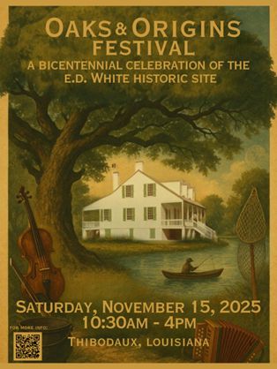
- Name/Logo on shared sponsor banner
- Website & social media recognition
- Recognition on event map
- 20 admission tickets
- 2 reserved parking spots
- 12x12 Booth Space
☐ Canopy Patron - $1,000
- Name/Logo on shared sponsor banner
- Website & social media recognition
- Recognition on event map
- 10 admission tickets
- 12x12 Booth Space
☐ Rooted Ally - $500
- Name /Logo on shared sponsor banner
- Website & social media recognition
- Recognition on event map
- 5 admission tickets
☐ Sapling Partner - $250
- Name /Logo on shared sponsor banner
- Website & social media recognition
- Recognition on event map
- 2 admission tickets
☐ Acorn of Tradition - $100
- 2 admission tickets
☐ Custom Sponsor $_______

COMPANY DETAILS
Company/Brand Name (as it should appear in materials):

Contact Name:

Email: Phone Number:

Mailing Address:

Logo Submission:
☐ Logo attached ☐ Will send later (preferred format: PNG/JPEG)
PAYMENT DETAILS
☐ Check Enclosed (payable to: Friends of E.D. White Historic Site)
☐ Invoice Me
☐ Paid Online (Confirmation #): _________________________________
Mail to: Friends of E.D. White Historic Site Pay online using
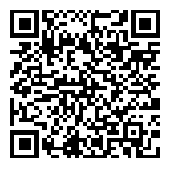
P.O. Box 5932 QR Code:
Thibodaux LA 70302-5932
AUTHORIZATION
I, the undersigned, agree to sponsor the above event as indicated:
Authorized Signature: __________________________
Name (Printed): ________________________________ Date: ____________________________________
Thank You for Your Support!

With gratitude and appreciation,
Pam Folse


Pamela T. Folse, M.Ed.
Friends of ED White Historic Site
President / Grant Writer
Email: ptfolse@yahoo.com
Phone: (985) 227-0958
Site Address: 2295 St. Mary Street
Thibodaux, LA 70301
Mailing Address: P.O, Box 5932
Thibodaux, LA 70302
Website: FriendsofEDWhiteSite.org

